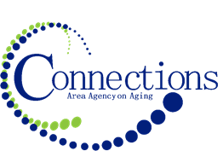

CONNECTIONS AREA AGENCY on AGING
BOARD MEETING
Via Video Conferencing in three office locations

DATE: Wednesday, May 29, 2024
TIME: 11:00AM – 12:30 PM
PLACE: Via Zoom

ITEM ACTION
I. Call To Order – Tom Hoogestraat
A. Roll Call - Kari Livermore
B. Recognition of Visitors
D. Approval of April Minutes – Approve/Amend Motion to Approve
E. Agenda – Approve/Amend Motion to Approve

II. Reports
- Mission Moment Kelly Butts-Elston
- Report on Sioux City/Onawa Housing Eric Lynner
- C.E.O. Report Kelly Butts-Elston
- Division Reports

III. Business Requiring Action
- Quarter 3 Fiscal Report Accept and File
- Lease Renewal Council Bluffs Approval

IV. Business Not Requiring Action
- Legislative Update Kelly Butts-Elston
- Preview of April Financials Jenny Rogers

V. Open Forum

VI. Adjournment

NOTE: If there is anything you want added to the agenda please call or email me kbutts@connectionsaaa.org (712-828-7038 or 712-828-1399) by May 28th and we can add it.

NEXT MEETING: WEDNESDAY, June 26 ^{th}, 2024

