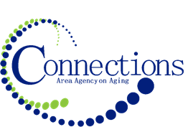

CONNECTIONS AREA AGENCY on AGING
BOARD MEETING
Pizza Ranch
3505 Metro Drive
Council Bluffs, IA

DATE: Wednesday, June 26, 2024
TIME: 11:00AM – 12:30 PM
PLACE: Pizza Ranch Party Room

ITEM ACTION
I. Call To Order – Tom Hoogestraat
A. Roll Call - Kelly Butts-Elston
B. Recognition of Visitors
D. Approval of May Minutes – Approve/Amend Motion to Approve
E. Agenda – Approve/Amend Motion to Approve

II. Reports
- Mission Moment Kelly Butts-Elston
- C.E.O. Report Kelly Butts-Elston
- Division Reports

III. Business Requiring Action
- April Financials Accept and File
- Approval of Contracts for FY2025 Approval
- Approval of New Phone System Approval

IV. Business Not Requiring Action
- Legislative Update Kelly Butts-Elston
- Preview of May Financials Jenny Rogers

V. Open Forum

VI. Adjournment

NOTE: If there is anything you want added to the agenda please call or email me kbutts@connectionsaaa.org (712-828-7038 or 712-828-1399) by June 25th and we can add it.

NEXT MEETING: WEDNESDAY, July 31st, 2024

