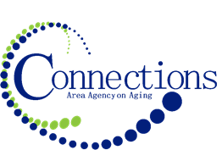

CONNECTIONS AREA AGENCY on AGING
BOARD MEETING
Via Zoom

DATE: Wednesday, January 31, 2024
TIME: 11:00AM – 12:30 PM
PLACE: In three office board rooms via conference call

ITEM ACTION
I. Call To Order – Kelly Butts-Elston
A. Roll Call - Kelly Butts-Elston
B. Recognition of Visitors
D. Approval of November Minutes – Approve/Amend Motion to Approve
E. Agenda – Approve/Amend Motion to Approve

II. Reports
- Mission Moment Kelly Butts-Elston
- Advisory Council Report
- C.E.O. Report Kelly Butts-Elston
- Division Reports

III. Business Requiring Action
- Fiscal Audits FY2021, FY2022 Motion to Approve
- Quarterly 2 Fiscal Report Motion to Accept and File
- Approval of Grant App to PCHTF Motion to Approve
- Approval of check signers at SN Bank Motion to Approve

IV. Business Not Requiring Action
- ADVC Grant Update Kelly Butts-Elston
- Legislative Update Kelly Butts-Elston

V. Open Forum

VI. Adjournment

NOTE: If there is anything you want added to the agenda please call or email me kbutts@connectionsaaa.org (712-828-7038 or 712-828-1399) by Jan. 29th and we can add it.

NEXT MEETING: WEDNESDAY, January 31, 2024

