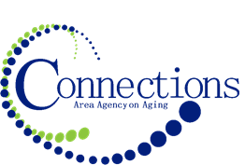

CONNECTIONS AREA AGENCY on AGING
BOARD MEETING
Boxer BBQ
513 S. Main Street
Council Bluffs, IA 51503
Upstairs Party Room

DATE: Wednesday, June 28, 2023
TIME: 11:00AM – 12:30 PM
PLACE: Boxer BBQ Party Room

ITEM ACTION
I. Call To Order – Kelly Butts-Elston
A. Roll Call - Kelly Butts-Elston
B. Recognition of Visitors
C. Approval of May Minutes – Approve/Amend Motion to Approve
D. Agenda – Approve/Amend Motion to Approve

II. Reports
- Mission Moment Kelly Butts-Elston
- C.E.O. Report Kelly Butts-Elston
- Division Reports

III. Business Requiring Action
- Approval of April Financials Ann Wilson/Jenny Rogers
- Approval of FY’2024 Contracts Kelly/Jenny/Ann

IV. Business Not Requiring Action
- Review of May Financials Ann Wilson/Jenny Rogers
- Staff Program Intros/Updates/Q & A Program Coordinators
- Legislative Update Kelly Butts-Elston

V. Open Forum

VI. Adjournment

NOTE: If there is anything you want added to the agenda please call or email me kbutts@connectionsaaa.org (712-828-7038 or 712-828-1399) by June 26 and we can add it.

