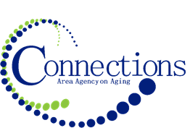

CONNECTIONS AREA AGENCY on AGING
BOARD MEETING
Via Zoom

DATE: Wednesday, Sept 27, 2023
TIME: 11:00AM – 12:30 PM
PLACE: Via Zoom

ITEM ACTION
I. Call To Order – Kelly Butts-Elston
A. Roll Call - Kelly Butts-Elston
B. Recognition of Visitors
C. Approval of Aug Minutes – Approve/Amend Motion to Approve
D. Agenda – Approve/Amend Motion to Approve

II. Reports
- Mission Moment Kelly Butts-Elston
- C.E.O. Report Kelly Butts-Elston
- Division Reports

III. Business Requiring Action
- July Financials Motion to Accept
- August Financials Motion to Accept
- Date of Combined Nov/Dec. Meeting Motion to Approve

IV. Business Not Requiring Action
- Discussion about Fiscal Reporting Jenny Rogers
- Legislative Update Kelly Butts-Elston

V. Open Forum

VI. Adjournment

NOTE: If there is anything you want added to the agenda please call or email me kbutts@connectionsaaa.org (712-828-7038 or 712-828-1399) by Sept. 26th and we can add it.

Next Meeting: Wednesday, Oct 25, 2023 at 11am to be held in the three boardrooms via video conferencing

