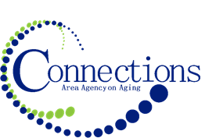

CONNECTIONS AREA AGENCY on AGING
BOARD MEETING
**Special Email Session to Approve Area Plan Budget**
Via email

DATE SENT: Friday, April 14, 2023
RESPONSE REQUESTED BY: Wednesday, April 19, 2023
PLACE: Respond via email

I. Business Requiring Action
- Approval of Area Plan Budget

Dear Directors,
Please review the attachment of the Area Plan Budget for FY2024 that is also attached to this email. If you approve of the funding levels and the rationalizations that were provided in the narrative please email me with your intent to approve. If you don’t approve, please email me with your “Nay” vote as well. If you have questions, please contact me or Ann

Kelly kbutts@connectionsaaa.org 712-828-7038 or 712-828-1399
Ann awilson@connectionsaaa.org 712-328-2540 ext. 8117

