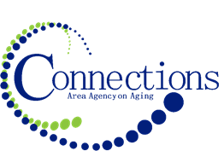

CONNECTIONS AREA AGENCY on AGING
BOARD MEETING
In Person at three office locations via Video Conferencing

DATE: Wednesday, July 31, 2024
TIME: 11:00AM – 12:30 PM
PLACE: Three office locations

ITEM ACTION
I. Call To Order –Kelly Butts-Elston
A. Roll Call - Kelly Butts-Elston
B. Seating of New Board Members
C. Recognition of Visitors
D. Approval of June Minutes – Approve/Amend Motion to Approve
E. Agenda – Approve/Amend Motion to Approve

II. Reports
- Mission Moment Kelly Butts-Elston
- Advisory Council Report Aubury Krueger-Kutchara
- C.E.O. Report Kelly Butts-Elston
- Division Reports

III. Business Requiring Action
- Fiscal Audit FY2023 Approval
- Election of Board Officers FY2025 Approval
- May Financials Accept and File

IV. Business Not Requiring Action
- Legislative Update Kelly Butts-Elston
- Preview of Year End Financials Jenny Rogers

V. Open Forum

VI. Adjournment

NOTE: If there is anything you want added to the agenda please call or email me kbutts@connectionsaaa.org (712-828-7038 or 712-828-1399) by July 30th and we can add it.

NEXT MEETING: WEDNESDAY, August 28th, 2024

