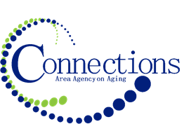

CONNECTIONS AREA AGENCY on AGING
BOARD MEETING
VIA ZOOM

DATE: Wednesday, July 26, 2023
TIME: 11:00AM – 12:30 PM
PLACE: Via Zoom

ITEM ACTION
I. Call To Order – Kelly Butts-Elston
A. Roll Call - Kelly Butts-Elston
B. Recognition of Visitors
C. Approval of June Minutes – Approve/Amend Motion to Approve
D. Agenda – Approve/Amend Motion to Approve

II. Reports
- Mission Moment Kelly Butts-Elston
- Advisory Council Report Rick Friday/Aubury
- C.E.O. Report Kelly Butts-Elston
- Division Reports

III. Business Requiring Action
- Approval of April Financials Jenny Rogers
- Approval of May Financials Jenny Rogers
- Approval of Addition to Procurement Policy Kelly Butts-Elston
- Approval of meeting schedule for FY2024 Kelly Butts-Elston

IV. Business Not Requiring Action
- Review of June Financials Jenny Rogers
- Legislative Update Kelly Butts-Elston

V. Open Forum

VI. Adjournment

NOTE: If there is anything you want added to the agenda please call or email me kbutts@connectionsaaa.org (712-828-7038 or 712-828-1399) by July 25th and we can add it.

